

**LAB#08**

**APPLIED PHYSICS LAB**

**Submitted to :Mr.Muhammad Shoaib**

**Submitted by: Group Of**

**Laraib Ijaz (2021-BSE-036)**

**Fizza Khan (2021-BSE-012)**

**Tanzeela Asgher(2021-BSE-032)**

**Date : 19th Feb,2022**

**TOPIC:Full wave rectification**

**Procedure:**

1. We took a resistor, four diodes and a capacitor and connected diodes like bridge type arrangement.

2. Wave form is observed by connecting the probe with an oscilloscope and circuit.

3. Waveform obtained was observed.

4. Experiment was performed for both positive and negative full wave’s rectification.

**Positive wave-form:**

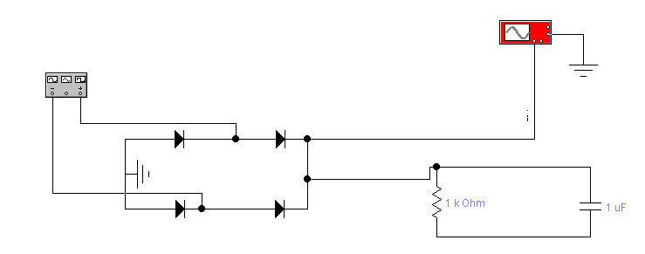

**Observations:**

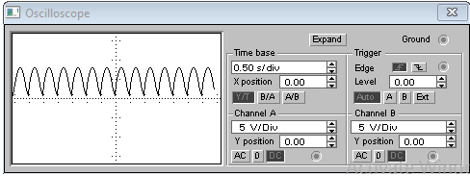

**Negative wave-form:**

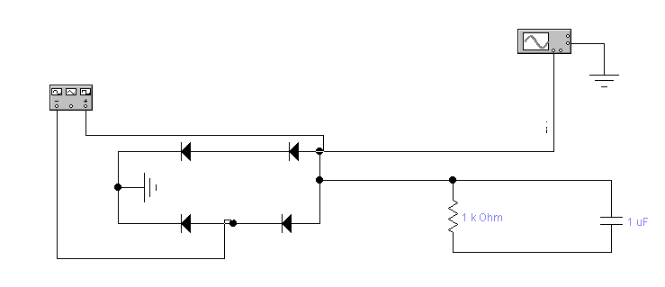

**Observations:**

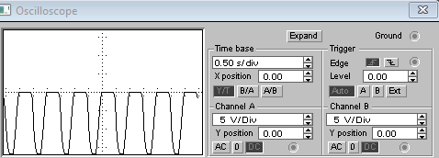

**Waveform with voltage source in circuit**

1. We took a resistor, four diodes,AC voltage source and a capacitor and connected diodes like bridge type arrangement.

2. Wave form is observed by connecting the probe with an oscilloscope and circuit.

3.Waveform obtained was observed.

4. Experiment was performed for both positive and negative full wave’s rectification.

**Positive waveform:**

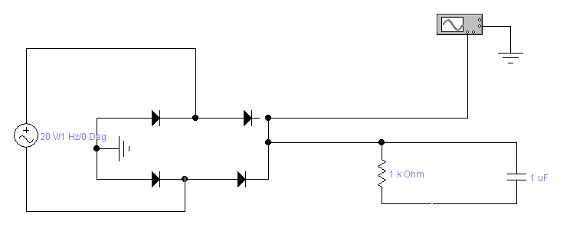

**Observations:**

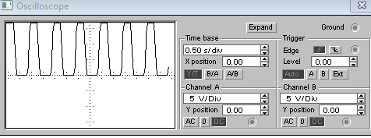

**Negative waveform:**

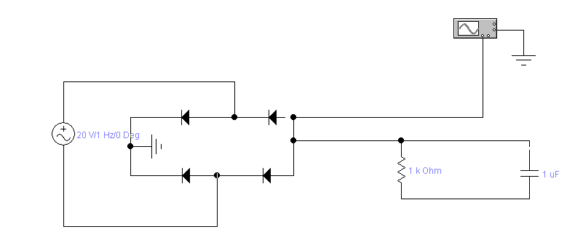

**Observations:**

